

# Physical geography Chapter 6: Drainage system in East Africa

**Drainage system** is a network well-defined channels through which water flows. The drainage system of an area is the outcome of the geological time period, nature and structure of rocks, slope, topography, amount of water flowing and the periodicity of flow.

**River** is a mass of water flowing over land through a defined and specific direction

## Cross profile of a river

It is a section showing the vertical shape of a river from one bank to another. It defines in terms of width of a river valley. It is characterized by the following: it’s narrow in the youthful stage and wide in the old stage. This is because in the youthful stage there is more vertical erosion than lateral. While in the old stage there more lateral erosion than vertical hence the valley is widened. It’s V-shaped in the youthful stage and U-shaped in the old stage. The youthful stage is deep while the old stage is shallow

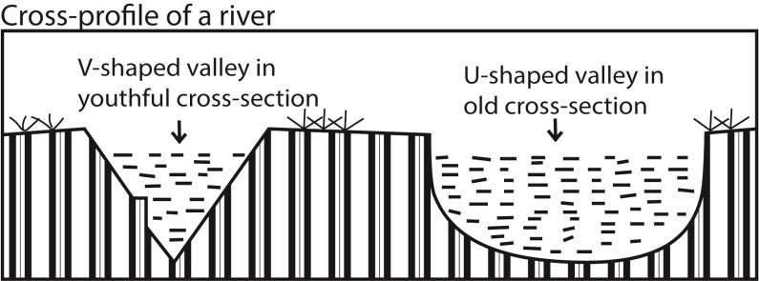

## Long profile of a river

It is a section showing the slope of a river from its source to its mouth. It’s is defined in terms of distance covered by a river. It has three stages: youthful, mature and old stage.

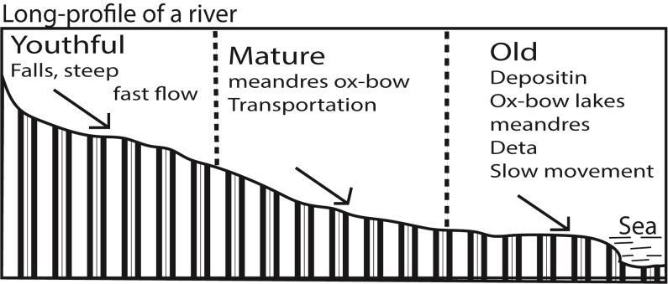

The youthful stage is characterized by:

* a very fast speed of river flow, - high volume of water,
* the river has a steep gradient.
* The rivers’ cross-profile consists of a deep narrow V-shaped valley. - The river tends to wind within interlocking spurs.
* Vertical erosion is dominant over lateral erosion
* Numerous rapids, waterfalls, gorge, potholes, interlocking spurs and plunge pools The mature stage characterized by
* Moderately steep slope
* The river channel is U-shaped
* moderate speed of river flow
* Lateral erosion removes interlocking spur.
* Meanders and river bends begin to develop

The old stage characterized by

* Very gentle slope
* Deposition occurs
* Very slow speed
* Wide valley
* Meanders, bluffs, slip-off slopes, ox-bow lakes and alluvia’s fans formed

## Reasons for nonexistence of a graded profile among rivers e.g. River Nile

A graded profile refers to well-developed concave slope from a river’s source to the mouth. It is sometimes referred to as a profile of equilibrium. Rivers try to attain a smooth river profile which is neither steep nor gentle by undermining highlands and eroding away obstacles while at the same time depositing the eroded sediments from upslope into the valley so as to attain a graded profile. However no river in East Africa Not even the Nile has attained a graded profile.

## Reasons for non-existence of a graded profile along R. Nile

* **Faulting within the river course.** Faulting along the Karuma led to an increase in the erosion power of the Nile. This led to creation of a waterfall and depression (plunge and pool) thus a graded profile not formed
* **Changes in climate.** River Nile flows through an area with different climatic characteristics. Such regions are characterized by heavy rain at the source (Jinja - L. Kyoga) and low rains towards the middle and old age. Such differences interfere with development of a graded profile.
* **Influence of river rejuvenation.** When a river renews its erosion power there is increased erosion of the channel both vertically and laterally. The Nile has under gone rejuvenation at a number of stages for example around Karuma falls due to uplift it flows into a valley thus it’s speed is increased leading to the formation of potholes, plunge pool which interferes with development of smooth graded profile.
* **Change in the base level.** Base level is the lowest point below which a river cannot erode. It is an imaginary line extending from the river mouth beneath the land whose altitude is zero. The sea is the universal base while lakes are the local base level. R. Nile crossed Lakes Kyoga and Albert whose base level changes due to a rise/fall in water level due to climatic factors. Such changes interfere with the formation graded profile. Example when the base level falls, the river gains momentum and so does more erosion; when it rises, the gradient of the river reduces leading to a reduction in the river’s velocity hence deposition occurs.
* **Differences in rock hardness.** Soft rocks are easily eroded to form a wide and deep river channel. On the other hand rocks tend to resist a rivers erosive ability. Since R. Nile passes through a region with different hardness it has not been able to attain a graded profile. For example rapids at Jinja resisted erosion and remain protruding on the river bed.
* **Presence or absence of vegetation and other obstacles.** The presence of vegetation and hard volcanic Islands at Jinja between the ‘source’ of the Nile and Bujagali falls has led to braiding of R.

Nile. Such circumstances have tampered with evolution of a graded profile.

* **River capture.** When a river arrests the waters of another adjacent river the energy of the capturing river is increased this leads to increased down cutting/erosion at the point of capture. This destroys a graded profile. The Nile captured river Tochi, Okole and Arocha thus an increased in its erosive power
* **Human activities.** Human activities like dam construction and irrigation tampers with the development of a graded profile. For example construction of dam like Nalubale and Kiira dams increase deposition upstream and erosion down stream

# Landforms resulting from river erosion and deposition along a long profile of a river The features formed depend on the stage of a river

**The erosional features formed in the youthful stage include gorge, waterfall, plunge pool, pot holes and interlocking spurs**.

# Gorge/canyon

A **Gorge/canyon** is a deep narrow V-shaped river channel (valley) with high vertical walls. It’s formed by vertical erosion in an area of relatively resistant rocks when a river flows at a very fast speed. Gorges tend to wind between interlocking spurs of highlands e.g. there is gorge near Murchison Fall on R. Nile. Other examples include the Manambolo gorge in Malagasy and the fish river canyon (gorge) in Namibia and Mitano gorge through which R. Birira flows

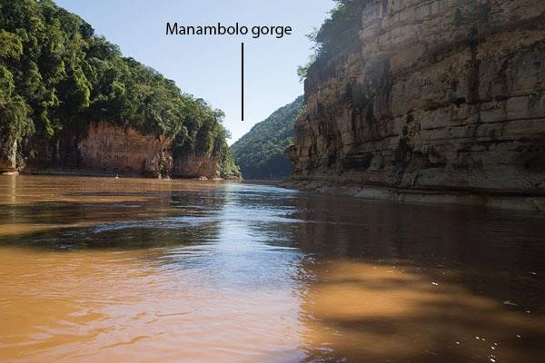

Conditions for formation of a gorge

1. Vertical erosion due to rapid flow of river water over relatively resistant rocks like lime stone in youthful stage of the river
2. River rejuvenation leading rejuvenation gorge where a river incises itself into the land surface due to a fall in base level e.g. Lupata Gorge along R. Zambezi
3. Gorges may also be formed due to outflow cut by a river draining a lake e.g. Lower Congo Gorge near Kinshasha.
4. Antecedent gorges are formed where a river has cut across a zone of rocks that are being slowly uplifted e.g. antecedent gorges along the Great Ruaha River in Tanzania
5. Superimposed gorges are formed where a river is superimposed onto a zone of hard rocks from a former covering rock layer e.g. Sabaloka Gorge along River Nile in Sudan.
6. Some gorges have been formed due to waterfalls retreating upstream e.g. Batoka Gorge below Victoria falls on R. Zambezi

# Waterfalls

**Waterfall** is a point in a river or stream where water flows over a vertical drop or a series of steep drops. Waterfalls are common in the upper course/youthful stage but can also occur in any part of the river profile. Some of the main water falls in Africa include Victoria Falls along river Zambezi, Murchison fall on River Nile and Sezibwa falls along River Sezibwa.

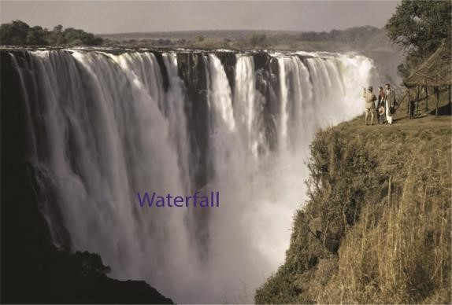

## Causes/conditions for formation of waterfalls

1. A sharp change in the resistance of rocks i.e. from a hard to soft rock. The hydraulic action of water massively erodes away softer rocks ahead of the hard rocks thus causing a change in gradient which forms a waterfall. Examples are Bujagali and Owen falls (Nalubale) or when there is an uplift of the land.
2. Faulting across the river bed may lead to vertical displacement of rocks along the faultlines. In this case a river flows from high to a low elevation thus a waterfall. Murchison fall along R. Nile was formed in this way.
3. It is also formed where a larva barrier or landslide cross a river where it may initially form a lake. Then a water fall is likely to form at the over pill from the lake where the river drops over the edge of the barrier e.g. Lily falls in Madagascar is formed this way.
4. Waterfalls may also be formed at the point where the river enters the sea at cliff line. A fall may develop near the mouth of a river if wave erosion out backs the cliff face or where the sea level has fallen. Examples occur in Cameroon Lobe river where Lobe falls were formed when it plunges over directly into the sea.
5. Waterfalls may also be formed due to river rejuvenation at the knick point

## Importance of water falls

These can be positive or negative

Positive importance

1. Potential for HEP generation e.g. Bujagali and Owen falls along R. Nile in Uganda.
2. Tourist attraction due to beautiful scenery formed e.g. Murchison falls
3. Sporting and recreation
4. Study purpose

Negative importance

1. Lead to hindrances in navigation e.g. on river Nile
2. Hindrance in fishing

# Plunge pool

**Plunge pool** is a hollow or broad depression formed at the base of a waterfall. Or an enlarged pothole at the base of a waterfall due to the progressive drilling and grinding of the valley floor by the hydraulic erosion and abrasive action of water. It’s found on rivers with waterfall in the youthful stage and along the rejuvenated section of a profile.

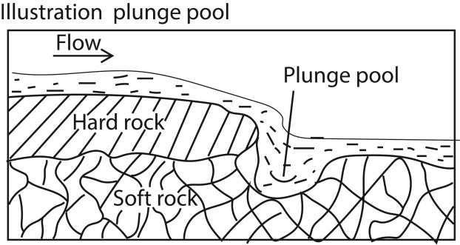

Plunge pool is formed under the following conditions.

* Large volume of water which increases the rivers’ competence.
* Steep gradient resulting into high erosive power of the river due to increased velocity.
* Large amount of abrasive tools like pebbles and boulders to grind the bed
* Difference in rock resistance in the river’s flow from a hard rock to soft rock thus drilling deeper underground.

Plunge pools are found along sezibwa falls, Ssipi falls, Kisizi falls and upper Tana river.

# Potholes

**Potholes** are circular depressions on the river bed. They are formed by swirling action of water along the river bed. The uneven bed of a fast flowing river cause the water to swirl (forward circular rotation). The pebbles carried by the river will start cutting circular depression which are gradually enlarged and deepened to form potholes.

# Interlocking spurs

**Interlocking spurs** are characteristic features of river flowing in a highland area. When a river flows through a series of highlands it tends to twist and turn around in the bid to avoid resistant obstacles. The river erodes the softer concave banks deposits on the relatively hard convex banks thus producing spurs on the either sides of the river. The deeply eroded concave banks stand up as Cliffs while deposition on the convex bank produces gently sloping extensions called slip off slopes. Examples of interlocking spurs are found on Mt. Rwenzori along R. Mubuku and river Nile between the source and Bujagali falls.

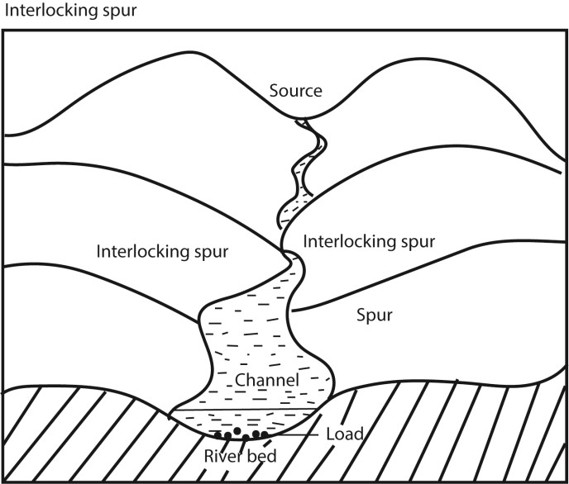

**The erosional features formed in the mature/middle stage include meanders, Bluffs or cliffs**

# Meanders

**Meanders** are curved bends of a river channel.

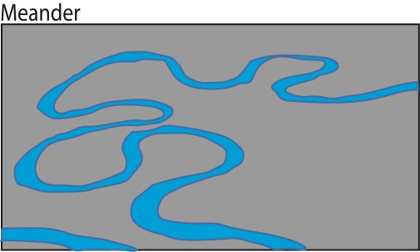

## Conditions for formation of meanders

* They are formed in the middle and lower/old stages of a river due to a decrease in gradient leading to reduction in speed of the river and river competence.
* Meanders may occur when a river avoids an obstacle or hard rock.
* Presence of large and excessive load within the river. When such loads are deposited along river bends, it begins to meander.
* Reduced competence
* Erosion of the concave sides causes cliffs while the deposition on the convex side cause slip-off slopes. The occur on R. Rwizi, Semuliki, Mpanga and R. Ngaila on the Kano plain

## Theories that explain development of meanders

* Reduced gradient along the river’s bed leads to reduced speed of the river. Once the speed is reduced the river energy reduces leading to deposits in the valley. Accumulation load causes the river to meander.
* Siltation along the river reduces the gradient causing the river to look for steeper gradient creating bends
* The existence and occurrence of hollows and shallow sections on the river floor i.e. pools and rifles that encourage meanders.
* Presence of alternate soft and hard rocks; easy erosion of soft rocks relative to hard rocks encourages river meandering
* Meanders also develop to minimize time and energy

# Bluffs or cliffs

**Bluffs or cliffs** are also formed within the mature stage. Bluffs are cut Spur end that extended down into the river valley. They are formed when a river erodes laterally to widen its valley. The river erodes more its concave banks and eventually it shifts direction of flow towards the convex bank.

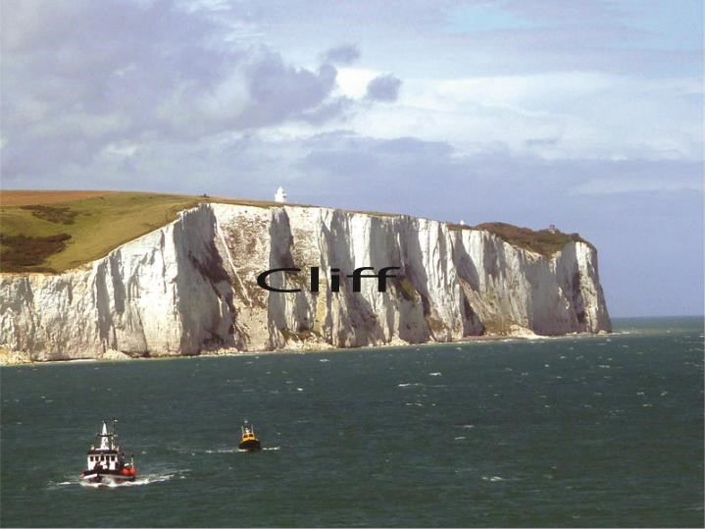

**The erosional features formed in the old stage are Meanders, bluffs, slip-off slopes, flood plain, Levees, ox-bow lakes, deltas and Alluvial fans.**

# Flood plain

A **flood plain** is gently is gently sloping plain of alluvium covering the valley floor down in which the river flows in a meandering channel. It’s usually flanked by ox-bow lakes formed along meander loops. Flood plains are formed when a river widens its valley by eroding on the concave bank and depositing on the convex bank. With time spur ends are cut thus widening the valley and depositing sediments in it.

Alternatively flood plains are formed when a river floods over its banks. The water spreads over the wide valley plain and sediment are deposited in the valley. Each time the river floods, and additional layer of sediments are deposited in the valley which later builds up the flood plain. Examples are found on R. Rwizi in Mbarara.

# Levees

**Levees** are raised ridges-like embankments composed of sediments on the sides of a river channel within the flood plain. They are formed when sediments a river deposits on the bank accumulate over a time due to continued floods. They may raise a few feet above the flood plain. Examples are found on R.

Malaba and Yala and on Kano plain of Kenya.

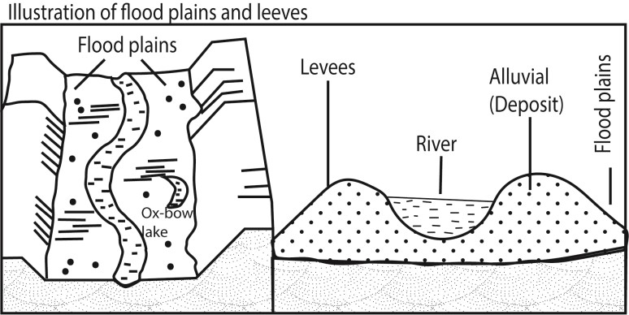

# Braided channel

A **Braided channel** is a wide shallow channel in which a stream, subdivides into a series of interconnecting small channels separated by deposits. They are formed when a river carrying large quantities of load reduce its competence. This leads to deposition of the load on the river bed in series. Once these accumulate, they form sand bars which separates the river into numerous streams. But these streams later join to form a big stream. Examples are found on R. Nile between Malakal and Khartoum, R. Zaire, Kilombero and R. Tana.

# Alluvial fan

An **alluvial fan** is a triangle-shaped deposit of gravel, sand, and even smaller pieces of sediment, such as silt. They are formed when a mountain Torrent deposits its load at a point where it enters into a main valley. Examples are found on Kilombero valley on Mahenge and UChungwe highlands in Tanzania. In Uganda there is Lume fan on R. Lume on the Semuliki Valley.

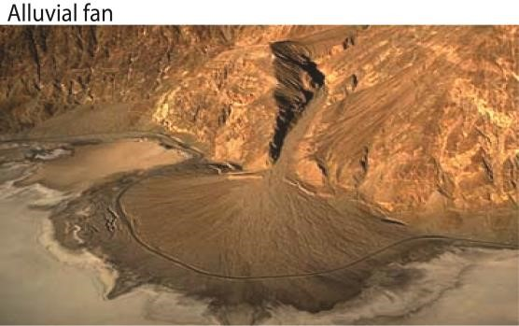

# Ox-bow lakes

**Ox-bow lakes** are horse-shoes shaped lakes or poo that forms when a wide meander of a river is cut off, creating a free-standing body of water. Examples are found on R. Semuli, R. Rwizi, R. Tana, Ngaila, R. Nyando, Nzoia, Mkomazi and Rufigi in Tanzania.

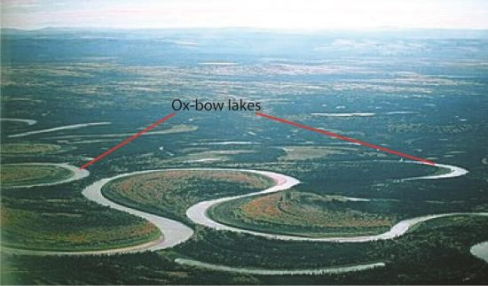

# Slip-off slope

**Slip-off slope** is a gently sloping relief feature made up of deposits on the convex bank of a meandering river channel.

It’s formed as a result of a river depositing sediments eroded from the concave bank on to the convex bank. When a river erodes sediments from the concave bank it creates a steep wall on that bank called a cliff. While when it deposits the sediment on the convex bank, it creates a gently sloping relief feature called the slip-off slope. For example on the eastern side of R. Nile (Busoga) around the source at Jinja is the slip-off slope while the raised wall on the western side (Buganda) is a cliff. In this case the slip-off slope is made up of boulders eroded from the concave bank.

**Wetlands**

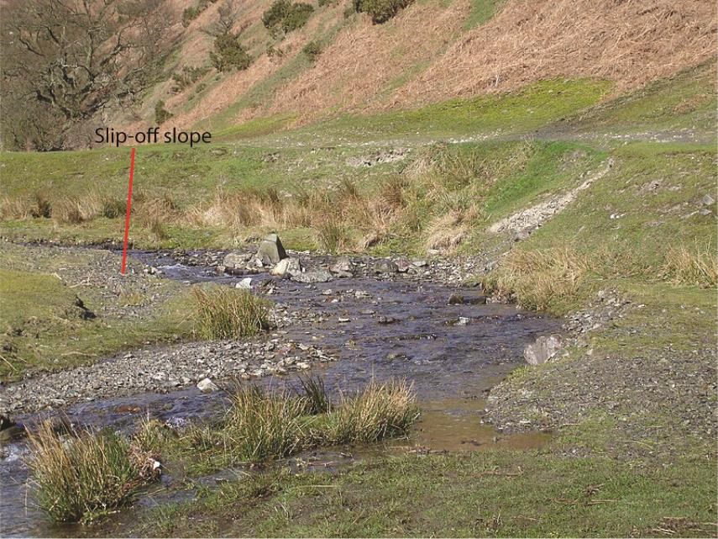

**Wetland is** a transitional area between terrestrial and aquatic eco-systems where the water table is usually at or near the surface or the land is covered by shallow water.

# Mouth of River

**Mouth of River** is the part of a river where the river enters into another river, a lake, a reservoir, a sea, or an ocean.

## Delta

**A delta** is a large flat/wetland that forms as a river empty its water and sedments into another body of water such as an ocean, lake or another river e.g. deltas are found on R. Omo as it enters L. Turkana and along R. rufigi in Tanzania, the Nile delta in Egypt, Niger delta etc.

## Deltas form under the following conditions

* Presence of large amounts of sediments within a river such as sand, gravel and silt
* Reduction in the gradient and speed of the river thus reduced competence - Presence off a sheltered coast such that deposits laid are not washed a way - Low tide currents such that the deposition is not carried away.
* Absence of obstruction or barrier like dykes at the mouth of the river.
* Presence of a shallow adjoining area/continental shelf along the sea where deposits are laid to accumulate.

## Process of delta formation

Where the river enters the water body, the water's flow decelerates, sediments drop out, and a delta forms, depositing a prism of sediment that tapers out toward the lake's interior. Progressive build-out of the delta through time leads to formation of sediments that are inclined in the direction toward the lake body.

**Types of Deltas**

The three main types of deltas are the arcuate, the bird's foot and the cuspate/estuarine

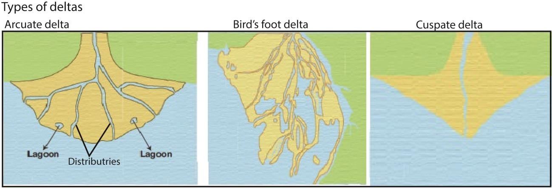

* The arcuate are the fan-shaped deltas. The wider portion of the fan is facing the water. It is formed from relatively coarse sediments e.g. Nile delta in Egypt, Semuliki delta on L. Albert, Rufigi delta, Niger delta etc.
* The bird’s foot delta got its name because it forms like a bird foot’s claw. It is formed by a river carrying very fine materials such as silt into water where wave energy is too weak to remove it. It is characterized by a few long tributaries bordered by levees extending some distance into the sea. Examples are found on river Omo as it enters L. Turkana from Ethiopia and Victoria Nile as it enters L. Albert.
* The cuspate/estuarine deltas are formed where sediments are deposited onto a straight shoreline with strong waves. The waves push the sediments to spread outwardly creating the tooth-like shape.

**Importance of Deltas**

* Contain fertile soils for agriculture e.g. Nile delta in Egypt
* Were centres of early civilization e.g. Nile delta in Egypt
* Source of sand and gravel used in construction industry
* **Biodiversity hotspot:** The river Deltas boast some of the most biodiverse systems on the planet

e.g. Sunderbans forests, one of the richest biodiversity hotspots in India.

* **Act as a buffer region:** The Deltas region provides a buffer for cyclones, as open land often stands to weaken the impact of storms as they travel toward larger, more populated areas. e.g. the Mississippi River Delta, for example, buffers the impact of potentially strong hurricanes in the Gulf of Mexico.

# Similarities between alluvial fan and delta

* Both are funnel shaped with apices at the source
* Both are made of sediments with finer materials deposited furthest while the course and heavy materials deposited near the apices.
* Both are formed at appoint where gradient drops and velocity of the river is reduced.

# Differences between alluvial fan and delta

* Alluvial fans develop on land away from the sea while deltas form at the mouth of a river where it enters into the sea.
* Alluvial fans have less distinct distributaries while deltas have marked distributaries
* Alluvial fans are formed in the youthful/mature stages of a river while deltas are formed in old/senile stage of a river.
* Alluvial fans are not flanked or associated with swamps, spits, bars, lagoons while deltas are associated or flanked with swamps, lagoons, bars, etc.
* Deposits in alluvial fans are mainly coarse material while deposits in deltas are mainly fine sediments
* Formation of deltas is determined by a number of factors such as presence of sheltered bay, absence of obstruction, absence of tidal currents and differences in salinity between the depositing rivers and the sea. However such factors are not applicable to alluvial fans.

# Summary of conditions that lead river deposition

* A drop in river’s gradient leads to reduction in the rivers speed, competence or energy to carry its load.
* An increase in the width of a river valley causes a reduction in speed leading to deposition
* Deposition occurs when a river enters into a stationary water body such as sea, lake and/or ocean because the speed of water reduces due to increased friction.
* Deposition takes place when fresh water enters salty water because clay particles and silt coagulate, become heavy and thus settle.
* Excessive evaporations leads to deposition because reduction in volume reduces the competence of the river to carry the load e.g. in river Omo in northern Kenya
* Increase in the concentration of load due to surface runoff, land slide and domestic wastes in urban areas.
* Nature of river bed; rough river bed characterized by potholes and rapids tends to traps the load leading to deposition

# River rejuvenation

River rejuvenation is the renewal of the erosive activity of the river within its old valley.

The causes of river rejuvenation

* **Heavy rainfall** (climate change) in the catchment areas causes increase in volume of water in the river. This increases the erosive activity resulting into rejuvenation.
* **River capture/piracy**: As the river cuts back, it breaks into the adjacent valley and captures a nearby stream. This increases the volume of water in the pirate river channel leading to rejuvenation
* **Regional uplift** along the river course e.g. through faulting causes a gradual steepening of the river's gradient. This increases its velocity (speed) and its erosive activity leading to rejuvenation.
* **Isostatic and Eustatic re-adjustments.** Negative changes in the sea level (fall in sea level) create a knick point close to the coast resulting into increase in the river gradient, increased speed and its erosive activity.
* Glaciation in the ice caps and ice sheets. This reduces the amount of water reaching oceans such as the Indian Ocean. This results into a fall in the sea level and lowering of the base-level of rivers. A steep gradient is produced and therefore, the velocity of the river and erosive load leads to an increase in the energy and erosive activity

**Effects/landforms due to river rejuvenation.**

* V-knick point is a sharp break of slope in the long profile of a river valley. It is a point in the river bed where the old river profile changes into a new river profile. Or a nick point is part of a river or channel where there is a sharp change in channel slope, such as a waterfall or lake.

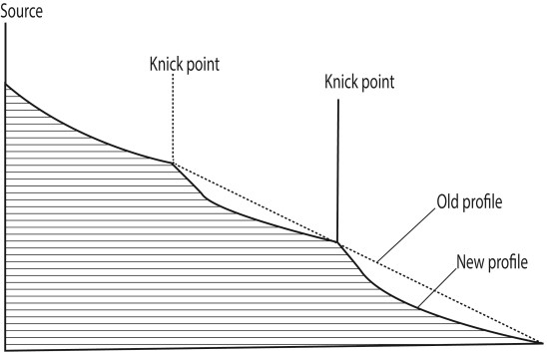

* Valley within a valley /rejuvenated gorge. This refers to a new valley which has been reshaped from the old existing valley. Along rivers where rejuvenation was fairly rapid and the fall in base level quite large, the effect may produce steep sided gouge within the former valley called valley which in a valley e.g. R.Nyando

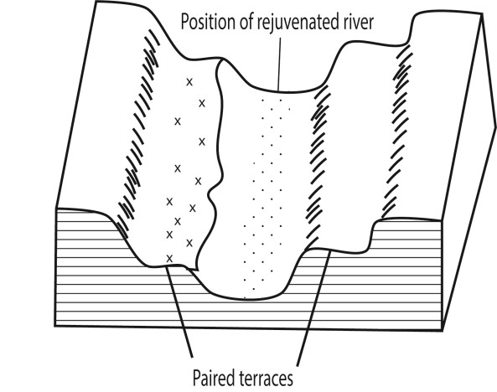

* **Stream terraces /paired terraces.** These are bench /step like strips of land found above a stream and its flood plain. They are benches cut in a rock or steps formed in sediments by deposition and subsequent erosion. Originally, the river deposited a thick section of flood plain sediments. Then the river changed from deposition to erosion and cut into its old flood plain, parts of which remain as terraces above the river .These terraces are generally of equal height and are called paired terraces e.g. R. Nyando
* **Incised meanders** .These are steep deep gorges cut into a meandering channel. They are formed when there is rapid vertical erosion of a channel within a meandering river. Th.is results to a meandering-valley with essentially no flood plains; e.g. R. Mwachin, Kombeni. Incised meanders are divided into two; (i) Ingrown meanders. This is a valley with an asymmetrical cross-profile, where one side is steeper than the other. It normally develops on more resistant rocks when vertical erosion increases, e .g. R Mubuku near the Kasese-Fort portal road, R. Manafa near Busia, along the Tororo - Mbale road.

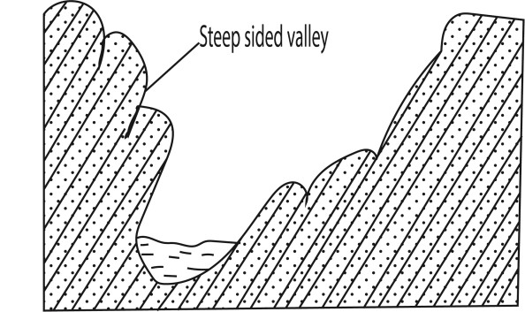

* **Entrenched meander**. These are valleys with steep sided symmetrical profiles .They develop on weak reeks where there's rapid lowering of the base level

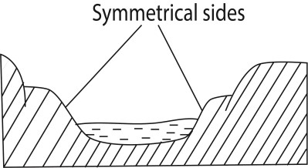

## Importance of river erosion and depositional features to human activities

Positive importance

* Waterfalls, rapids and narrow gorge are used for HEP
* Beautiful scenery of waterfalls, rapids, meander are tourist attraction sites
* River valleys have fertile soils for agriculture
* Delta such as that Semuliki contain petroleum deposits
* Delta and river valleys contain sand and clay as building materials
* The mangrove vegetation in the river Rufigi provide poles for construction - Delta are used for fishing

Negative importance

* Rapids and waterfalls hinder transport.
* Deep valleys limit settlement
* Flooding limit agriculture and settlement

# Drainage pattern/system

Drainage systemis the physical outlay of a riverand its tribbutaries on the earth’s surface.

- 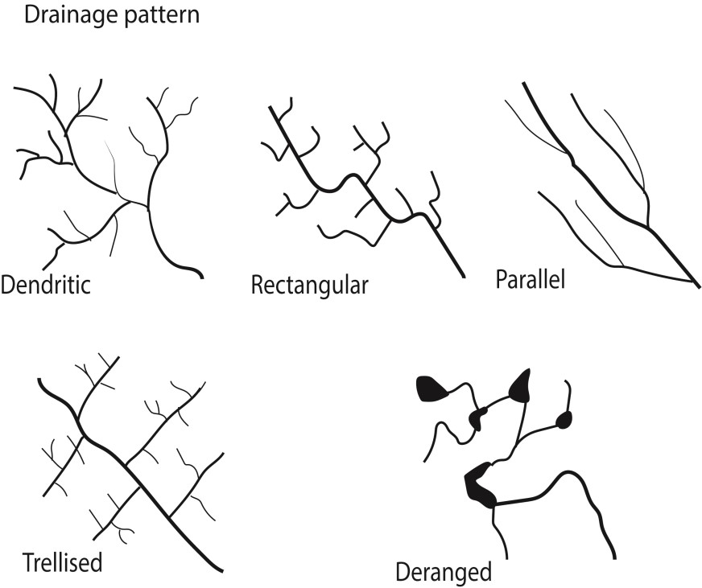

## Radial drainage pattern

**Radial drainage pattern** occurs when several rivers originate from the same dome-shaped water shed and flow outwards. It is a drainage pattern associated with mountains. Examples of radial patterns are found on Mt. Elgon comprising rivers Sironko, Manafa, Siti and Koitobos and on Mt. Rwenzori comprising Rivers Mubuku, Nyamugasani, Lume and Ruanoli.

Factors favoring radial drainage pattern

* the presence of a dome or cone shaped highland that provides source of the rivers
* steep slopes that accelerate downward movement and erosion of rocks to create channels along which rivers flow.
* Presence of high highland with uniform rock structure and hardness to enable a river erode on any side of the highland.
* High precipitation in catchment area in form of rainfall, snow or melting glacier to provide constant water supply.

## Centripetal drainage pattern

Occurs when several rivers from different directions flow towards a common point e.g. on L. Victoria comprising Katonga, Kagera, Nzoia and Sio.

Factors favoring formation of centripetal drainage

* Presence of depression, basin or valley into which rivers flow.
* Heavy rain fall and reliable rain fall to provide constant supply of water
* Regions with rocks of uniform resistance to erosion

## Dendritic drainage pattern

Here tributaries join larger streams at acute angles like braches of a tree. Examples are found on R. Rufigi, Victoria Nile, R. Malagalasi, R. Kagera, R. Congo etc.

Factors favoring formation of dendritic drainage system

* develops in areas where the rock beneath the stream has no particular structure and can be eroded equally easily in all directions.
* Gentle slope
* Heavy rain fall and reliable rain fall to provide constant supply of water in large catchment area.

## Trellis/rectilinear drainage patterns

It is pattern which displays a rectilinear shape with tributaries joining the main stream at approximately right angle. Examples occur on R. Mayanja-Kato, Wasswa in Kichwamba, R. Aworanga, Pager, Aswa and Galana.

Factors that favor development of trellis drainage pattern

* Presence of sedimentary rocks that have been folded or tilted, and then eroded to varying degrees depending on their resistance to erosion.
* Heavy rain fall and reliable rain fall to provide constant supply of water in large catchment area.

## Parallel drainage patterns

It is a drainage pattern where rivers flow by the sides of each other but with limited chances of joining one another. Examples are found in western Uganda where R. Nkusi and R. Hoima are parallel to each other before joining L. Albert. In Kenya they are found in the Aberdare ranges and west of Mau ranges where tributaries of R. Athi such as R. Nairobi, Thirika, Komu and Ruiru flow parallel to each other

Factors favoring formation of parallel drainage system

* Presence of pronounced slope to the surface of uniform rock resistance or in regions of parallel, elongate landforms like outcropping resistant rock bands.
* Rivers flowing in the same direction
* Pronounced divide made of hard rocks between the rivers to limit chances of the rivers joining each other.
* Heavy rain fall and reliable rain fall to provide constant supply of water.

**Deranged drainage pattern** (has no clear pattern) forms in areas with extensive limestone deposits, where surface streams can disappear into the groundwater via caves and subterranean drainage routes or in areas where there has been much geological disruption or areas with low relief, low slopes, and large sediment loads.

**Rectangular drainage Pattern** forms where the bedrock is faulted and jointed.

## River capture

River capture/stream piracy occurs when a stronger river flowing in a deep channel arrests the waters of an adjacent weak river.

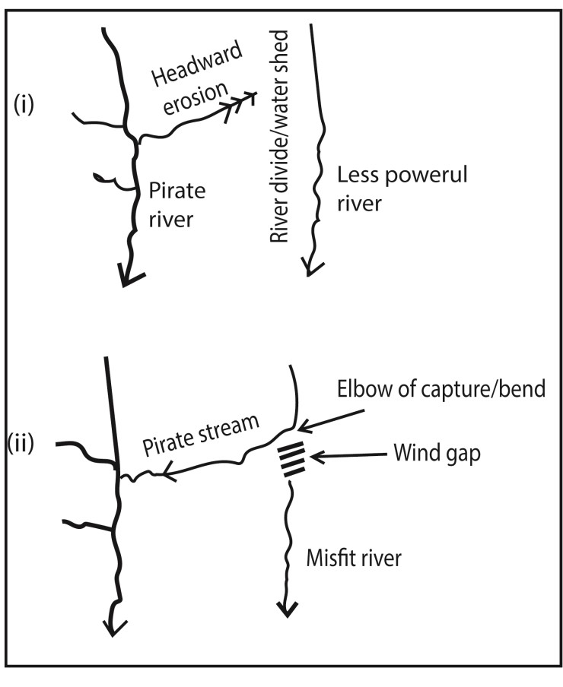

Factors leading to river capture

* River capture occurs where there are 2 adjacent rivers/ share a watershed moving in the same direction; e.g. R. Aswa and R. Agogo
* One river has more erosive power than the others e.g. a powerful R. Nile capture the weak rivers i.e. R. Okole, Tochi and Arocha.
* Differences in rock hardness. A river flowing over soft rocks deeply cuts it’s valley by headward erosion into the valley of one flowing over hard rocks capturing it in the due course. For example R. Wasa flowing on soft rocks eroded and captured R. Nyaboranga in Fort Portal in west Uganda
* River capture can result from river rejuvenation since a rejuvenated river gain strength to capture others
* River capture may also occur as a result of earth movements such as uplift or down warping along the course of one river. A river flowing over a down warped channel may extend its valley by head ward erosion and capture waters of an adjacent weaker river flowing over an uplifted channel e.g. R. Birira in south-west Uganda captured R. Rwizi.
* Difference in gradients along which rivers flow; a river flowing along a steeper gradient is likely to capture a river flowing along less steep gradient. Examples are found in Ghana where R. Nsaki a tributary of R. Dunsu in the Akwapim hills (steeper gradient) captured the Basiasi (gentle gradient)
* Influence of rock joining. A pirate stream/river is flowing over well jointed rock may undertake head ward erosion, deepens it valley and eventually captures a weaker river flowing on massive rocks.
* A pirate stream flowing in a short and direct course can easily capture a weaker river flowing in a long and circuitous course

## Process of river capturing

* The more powerful river erodes vertically faster than weaker one thus flows at lower level than the other.
* The more powerful river erodes it's valley towards the other river's valley through head-ward erosion
* Eventually, the powerful river joins valley of weaker river
* The powerful river diverts the head waters of the weaker river into its channel • The diversion of the headwaters is called river capture.

## Terminologies of river capture

* A **pirate stream**; this is the river through head ward erosion that captures water of another nearby river.
* **Beheaded stream /misfit stream**; this is the victim stream which has lost its waters due to capture.
* A **wind gap**; This is the dry valley of the beheaded stream below the point of capture
* **Elbow of capture** is the bend formed at a point where the headwaters of the captured stream flow into the capturing stream
* **Gorge /incised valley**; Undercutting of the pirate river near the point of capture due to increased water volume which results into renewed erosion producing a steep and deep valley.
* **Knick point**; a sharp break in the slope created near the point of capture due to rejuvenation.
* **Over Fit River**, this is the river that appears too big for its present valley due to increased volume of water from the captured river.

***Examples of river capture in east Africa include***

* Lower Tiva captured upper Tiva River in eastern Kenya, formally a tributary of river Galana.
* River Aswa captured Agago, Moroto and Pager rivers in northern Uganda; reversed river- Rwizi, Katonga captured weaker adjacent rivers when Western Uganda uplifted.
* River Ruaha captured Pawaga drainage system in Tanzania.
* River Nile captured waters of river tochi, Okole and Arocha etc

## Importance of river

Positive

* Water transport e.g. R. Tana
* Fishing e.g. R. Nile
* Recreation e.g. R. Nile
* Production of HEP e.g. R. Nile
* Source of building materials such as sand and clay
* Tourist attraction
* Source of minerals such as diamond, gold from alluvial deposits
* Fertile soils in the basins and delta for agriculture

Negative

* Water falls hinder navigation
* May cause flood that destroy crops and animals

# Revision questions

1. (a) Differentiate between cross profile and long profile of a river.
   1. Account for the nonexistence of a graded profile along River Nile

(Define the key words such as river, river cross profile, long profile, and graded profile. Differentiate between the two. Describe the factors that interfered with development of a graded profile along

R. Nile. Use examples and diagrams to illustrate your points.)

1. Explain the causes and effects of river rejuvenation in East Africa Candidate are expected to define river rejuvenation

(Identify and explain, with illustrations the effects of river rejuvenation)

1. (a) Examine the formation of land forms resulting from river erosion and deposition along a long profile of a river.
   1. Examine the effects of river erosional and depositional features on human activities.

(Describe a long profile of a river and identify its stages. Outline the characteristics of each stage. Describe the processes through which river erosion and deposition operates. Explain the formation of the features. Examples and diagrams may be used to illustrate the point)

1. (a) Describe the conditions for formation of a waterfall.
   1. Examine the importance of a waterfall on economic development in East Africa.

(Define a waterfall; describe the conditions for formation of a waterfall; give positive and negative importance of waterfall)

1. Examine the similarities and differences between an alluvial fan and delta

(Define alluvial fan and delta; then give similarities and differences between the two)

1. Account for the process of river deposition and describe the formation of its resultant landforms

(Define a river; explain the reasons why rivers are able to carry d

1. Account for the occurrence of river rejuvenation and describe the formation of the associated features

Thank you

Dr. Bbosa Science